**SRI A.S.N.M.GOVERNMENT COLLEGE (A),PALAKOL**

(NAAC Re-Accredited with NAAC “B” Grade (CGPA 2.61)

WESTGODAVARIDist., A.P., Pin.534260

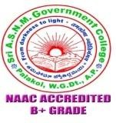

**DEPARTMENT OF BOTANY**

FIELD VISIT 30.11.2021

29-11-2021

Palakol

To

The Principal

Sri A.S.N.M Govt. College (A),

Palakol, W.G. Dt.

Sub:- Request for seeking permission of field visit for B.Sc Students to Coconut nursery & Pond ecosystem at Kaza village.

I wish you to bring to your notice that a batch of 31 students III B.Sc (CBZ) of Sri A.S.N.M Govt. College (A), Palakol, W.G. Dt. Along with 2 faculty members of Department of Botany and Zoology are going to visit Coconut nursery & Pond ecosystem at kaza Village on 30-11-2021 as part of their curriculum.There are no foreign students in the group.

Hence I request you to extend your cooperation and permit us to vist the place/Organization which is useful to the students.

Thanking You

Yours sincerely,

SRIA.S.N.M.GOVERNMENTCOLLEGE(A),PALAKOL, W.G.Dt

(NAAC Re-Accredited with NAAC “B” Grade (CGPA 2.61)

PALAKOL,WESTGODAVARIDist., A.P., Pin.534260



DEPARTMENTOFBOTANY

FIELD VISIT 30.11.2021

Sri A S N M GDC (A), PALAKOL Department of Botany conducted field visit to Coconut nursery at kaza village for 3rd B.Sc students on 30-11-2021. 31 students from III B.Sc(BZC) group along with 2 lecturers ofDept of Botany Dr. Y Vijay kumar, Dept of Zoology Dr.M Ramakrishna have participated in this field trip, to get the knowledge about Coconut nursery management and Pond ecosystemas a part of their curriculum.

Signature of the Faculty: 1.

2.

SRIA.S.N.M.GOVERNMENTCOLLEGE(A),PALAKOL, W.G.Dt

**DEPARTMENT OF BOTANY**

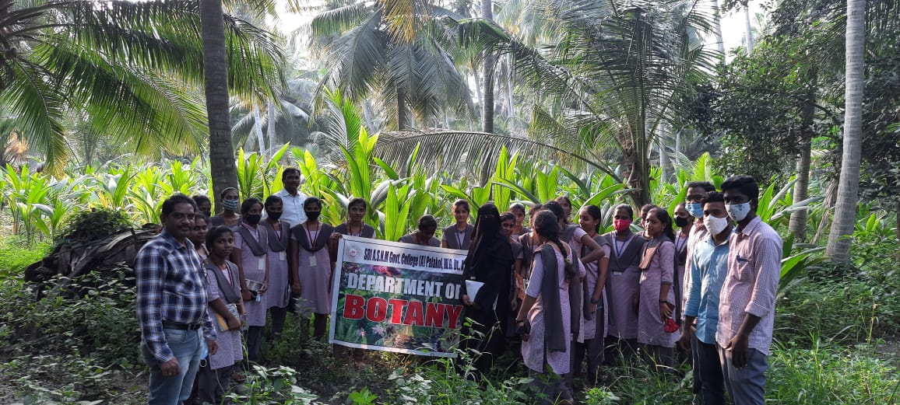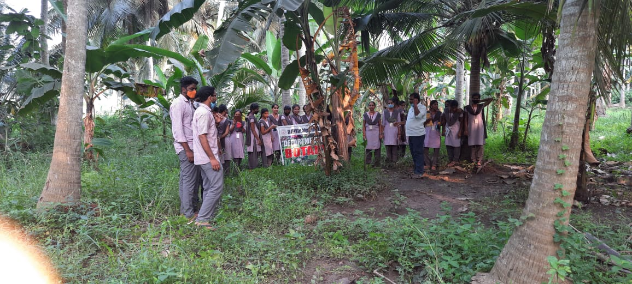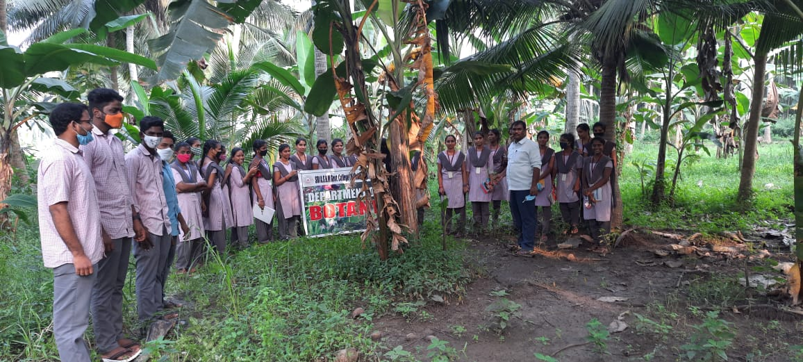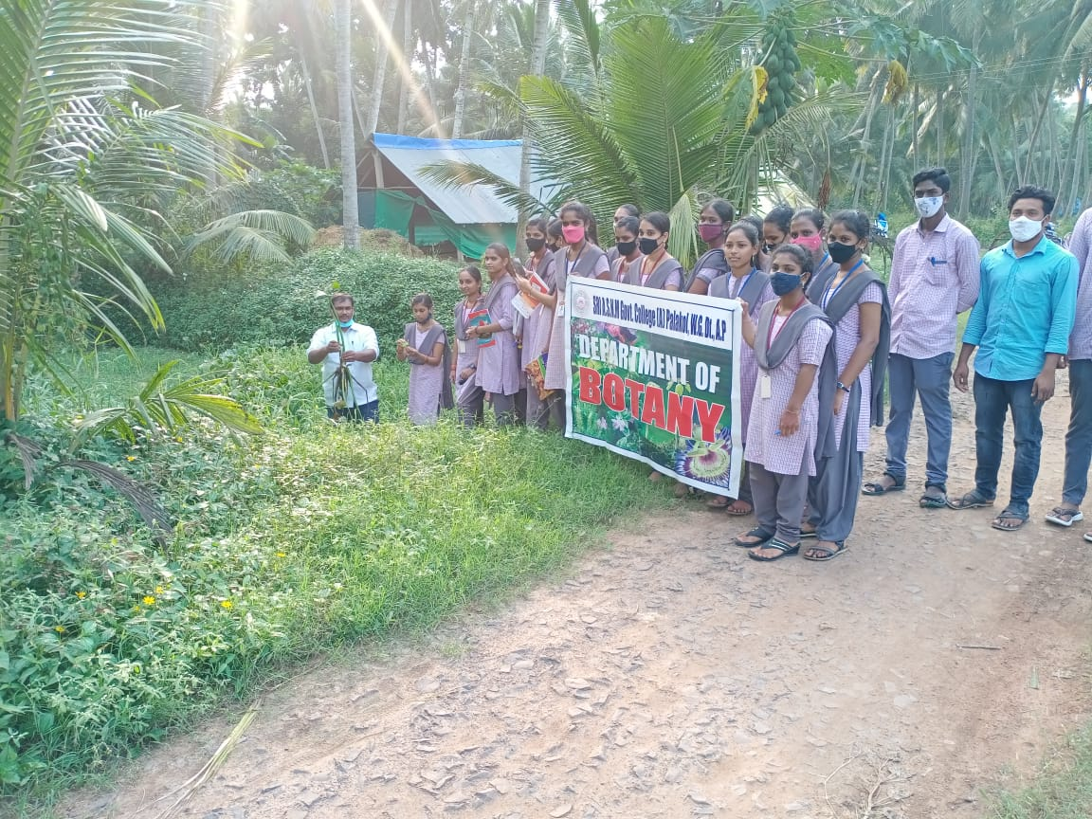FIELD VISIT:- POND ECOSYSTEM & COCONUT NURSERY, KAZA VILLAGE 30- 11-2022